Retail Sales Data Analysis
Project Description: This project focuses on analysing transactional retail data to uncover meaningful business insights related to revenue performance, product demand, customer value, and geographic sales distribution. Using Python-based data analysis libraries such as Pandas, NumPy, Matplotlib, and Seaborn, the dataset is explored, cleaned, transformed, and analysed to support data-driven decision-making.

The primary objective of this project is to evaluate overall sales performance and identify key drivers of revenue.

Visuals:
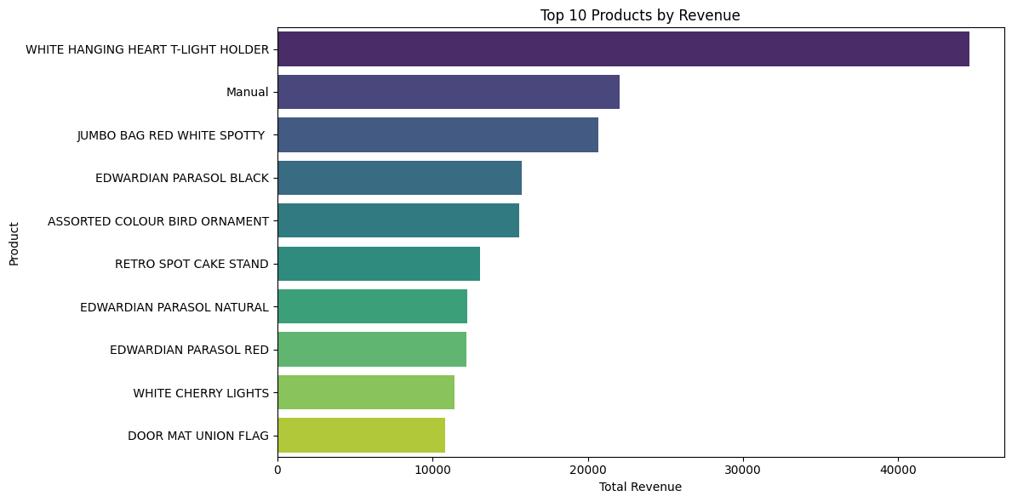

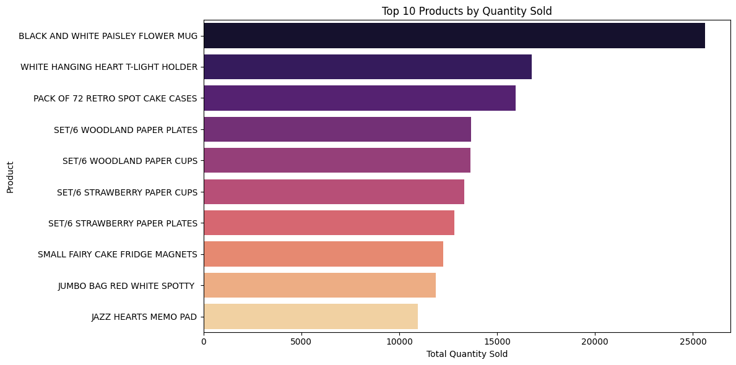
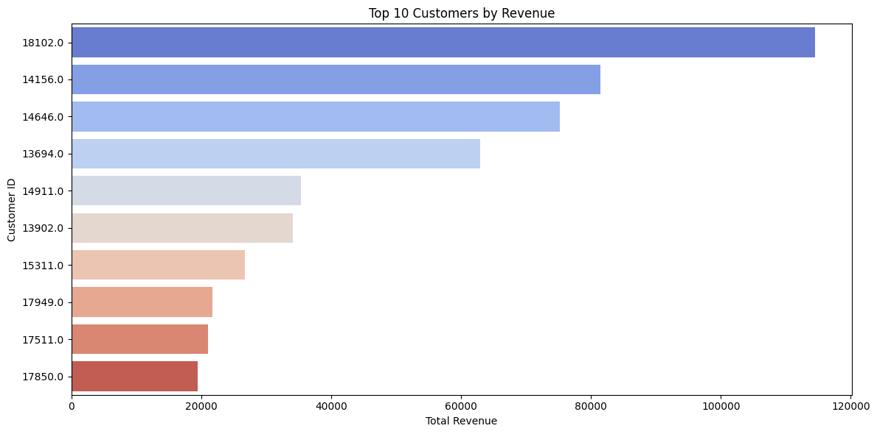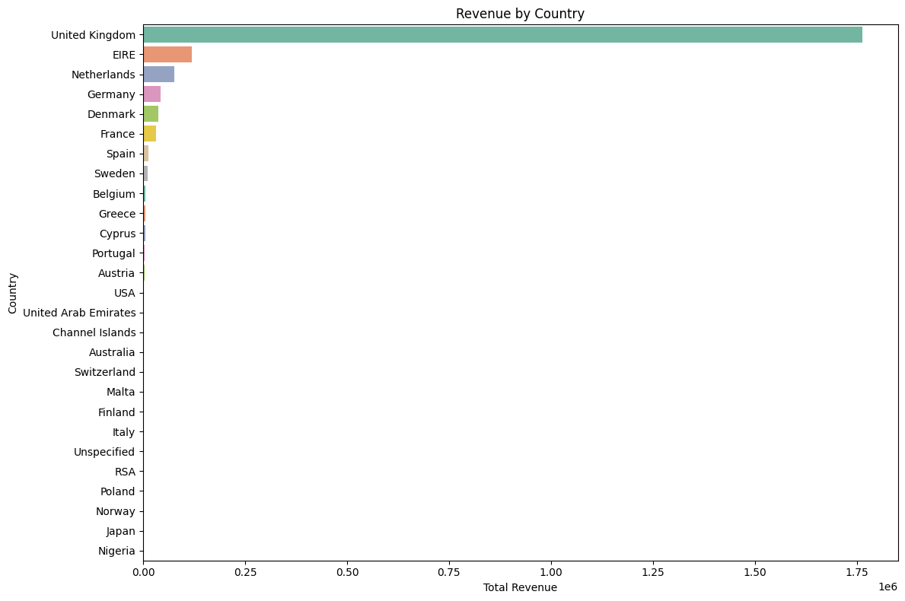

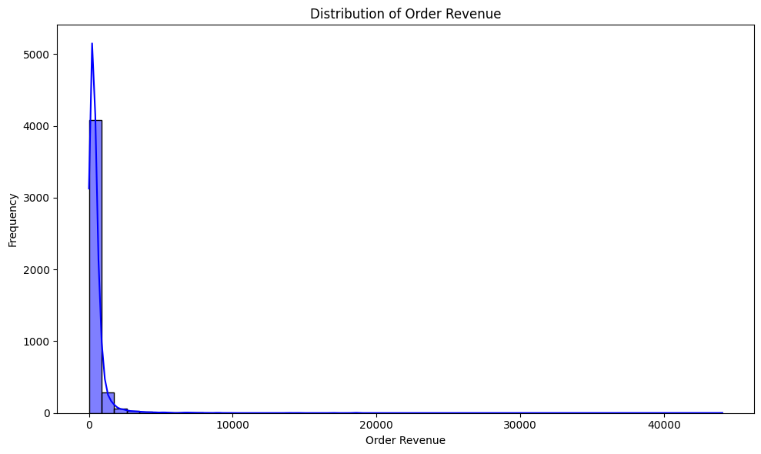

Usage:
The usage of this code is to **analyse retail transaction data to understand sales performance**.
It helps calculate total revenue, identify top products and customers, analyse country-wise sales, and measure average order value—supporting better business decisions.

Features:
This code performs **retail sales data analysis** using Python libraries like Pandas and NumPy.
It cleans the dataset by removing cancelled transactions and creates a new revenue column (`Total Sales`).
The code calculates key business metrics such as **total revenue, top-selling products, top customers, country-wise sales, and average order value (AOV)**.
Overall, it converts raw transaction data into meaningful business insights for better decision-making.

